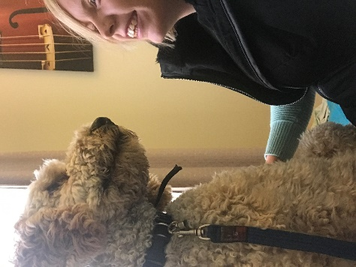

**Annie’s dogs: therapy dog TRAINING**

**Principles**

* **What is a therapy dog?** Therapy dogs are not service dogs. Service dogs are trained to respond to assist a person with a life altering disability i.e. seeing-eye dogs, diabetes dogs, epilepsy dogs. These dogs are allowed anywhere – supermarkets, cafes etc. Therapy dogs are at the opposite end of the spectrum. They are trained to provide non-life saving affection, comfort and support to all people. Importantly, they are not allowed entrance into all facilities, rather they must receive prior permission from the facility for entrance.
* **Is my dog suitable for therapy dog training?** If your dog enjoys human attention and has the right temperament- being friendly, patient, and confident in all situations, then your dog may be suitable for therapy dog training. **To undertake my therapy dog training your dog does **not** **already** have to be obedient as I will teach your dog obedience during the training.
* **What does it take to be a therapy dog?** Therapy dogs must have:
  + **Impeccable obedience.** Therapy dogs should not jump on people, bark, bite, or refuse to listen to their owner. They should be able to remain in their drop or sit position without attention and only move from that position when allowed. They should be toilet trained.
  + **Flawless temperament.** Therapy dogs must be friendly, patient, confident, gentle, and at ease in all situations.
  + **Enjoy human attention**. Therapy dogs must enjoy human contact, love being petted, cuddled, and handled by familiar and unfamiliar people.
* **Where do therapy dogs work?**  Therapy dogs are often found in schools, nursing homes, hospitals, prisons, libraries, counselling and psychologist facilities and are increasingly becoming a part of many organisations that have public contact.
* **What am I qualified to do after this training?** Importantly, this training does NOT qualify you as a teacher/counsellor/psychologist/aged care worker etc. Instead, this certificate credits you as a therapy dog handler, and your dog as a therapy dog. This means you can enter facilities – with prior permission from the facility – as a therapy dog handler. If you are ALREADY a teacher, counsellor, psychologist, aged care worker etc this qualification will enable you to take your dog with you to work (given your employer has granted you permission to do so). If you do not have a prior qualification, this certificate enables you to seek permission of public access facilities to bring your therapy dog into their facility to provide generalised wellbeing through dog-human contact.
* **What are the legal requirements of therapy dogs?** Therapy dogs are not service dogs. This means they do not have access to facilities which serve or prepare food, nor are they considered exempt from public housing or national park requirements. Before a therapy dog can enter a public space, they require prior approval from the administration of your building.
* **When you book your course you are booking specific dates.** If you need to change your dates for any reason up to **two months before** the course starting you will incur a $200 transfer fee (if I can fill your spot there will be no transfer fee required). If you need to change your dates for any reason **after this cut off point** you will incur the full cost of a deposit for the future dates. This may appear harsh, however, I have often had to run courses with only 3 paying customers in it and the others all late date swappers. This has left some courses quite empty and others super full and has taken spaces that otherwise could have been filled. The cost of your therapy dog jacket, venue hire and my transport costs are all considered in setting this non-refundable deposit. Going forward, your non-refundable deposit of $1000 is that: non-refundable, unless I can fill your place. In the event of being able to fill your place no cost will be incurred to change your dates).
* **Covid restrictions.** In the event of Covid restrictions interrupting our plans there will be three options available to us.

1. A voucher which can be used for any future course.

2. A rescheduling of dates.

3. A refund of partial moneys.

Preference will go to options 1 and 2. Regarding option 3:

1. If the course hasn't started yet, you will be reimbursed $1,300. The $300 non refunded will go to the cost of running the event including venue hire, jacket cost, transport etc.
2. If the course has started you will be reimbursed $750. The $850 non refunded goes to the costs outlined above, and takes into consideration what you have already received (on day 1 you will receive a resource pack, intensive training in dog obedience, as well as all of the principles required for dog obedience).
3. If the course has made it to our testing days (the last two days of the course) you won't be offered a refund but a one day testing day will be organised at a future date at no extra cost to you.

* **Fail grade.** It is entirely possible **(though unlikely)** for your dog to fail. This may be due to your dog’s obedience, temperament, or enjoyment of the role not meeting therapy dog standards. There is no guarantee that joining the course will ensure graduation. If you do receive a fail grade, advice will be made available to you specific to why your dog failed (i.e. tips on how to socialise your dog, obedience courses etc). It is up to you whether you would like to continue to pursue therapy dog status or not. If you would like to re-test for therapy dog competency, this will be at a cost of $100 for a re-cert day.

This course certifies you as a Therapy Dog Handler, and your dog as a Therapy Dog.

The course is conducted over 5 days. It teaches your dog impeccable manners, obedience and refines their dog-human skills.

Included in this training is a strong focus on dog obedience. If your dog has already completed Annie’s Dogs: 3 days and a new dog training the obedience taught will be off-lead obedience. If your dog has not already completed Annie’s Dogs: 3 days and a new dog training the obedience taught will be with a halti and lead.

**Visit: Annie’s Dogs: Therapy Dog training on Facebook for more information.**

The Gist:

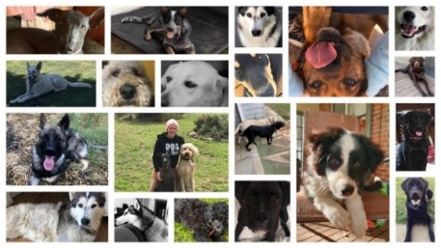

Level of physical capability required

Can my dog fail?

Contact:



# **Annie’s Dogs: Therapy Dog Training Registration Form**

Dog’s Name: ____________________

Dog’s Age: _________________

Dog’s Breed: _____________________  
I consent that (please tick each one):

* My dog is 5 months of age or older
* My dog enjoys human-dog contact
* My dog is not dog or people aggressive
* My dog enjoys human interaction
* My dog is up to date with their vaccinations

My Name: ______________________________________

My Occupation: __________________________________

Setting where I wish to work/volunteer with my dog: __________________________________________________

How much time (on average) I spend with my dog per day: _____________

I consent to (please tick each that apply):

* Having videos/photos taken of myself and my dog during the training.
* Having those videos/photos posted on Annie’s Dogs Facebook pages.

I recognise that all costs incurred in the event of my dog harming another person/dog/property will be payable by me (the dog’s owner). I release Annie’s Dogs from any legal or financial liability resulting from the training including personal injury. I agree to the principles outlined in the attached page, including but not limited to the cost incurred if I need to change my dates, or if my dog fails.

Signed: ________________ Date: ______________

Full Name: _________________________________



What you can expect at the end of 3 sessions:

* A dog who heels when walking on a loose lead.
* A dog who no longer jumps.
* A dog who sits/drops on command and does not get up again until commanded.
* A dog who ignores distractions and remains focused.
* A dog who can be petted by family/friends and strangers without becoming too excited.
* Membership into an online community of past graduates.
* Free weekly challenges and further access to dog training resources.
* Dog socialisation with many other dogs.

What is expected of you:

* Use a halti-harness.
* Be willing to implement at home the techniques taught (at least 30 minutes each night).
* Attend each session with your dog.
* Allow your dog inside with you. This training does not work well with dogs who do not get to spend time with their owners.
* Blackdog Head Halti Harness and lead (see below).
* Favourite toys, food and treats.
* Long lead (or multiple leads – we’ll clip them together).
* Water bowl, water, poo bags, etc.
* Dog bed.
* Lunch/snacks for yourself.

* Phone: Annie Silva- 0473 739 067
* Facebook: Annie’s Dogs: Therapy Dog Training
* https://anniemay900.wixsite.com/website
* It is possible your dog may not pass the requirements to become a therapy dog. However, a re-evaluation can be conducted at a later date.
* Reasons for your dog receiving a fail grade will be based on their obedience, temperament or apparent non-enjoyment of the therapy dog role.
* Communication and support will be offered before any fail grades are given. A fail-grade is unlikely, but possible.

distractions for 30 minutes until you say ‘Free’.

* This training does require a moderate level of physical capability. If you are concerned, please talk to me about your limitations to ensure this training is appropriate for you.
* Please bear in mind, the stronger and more stubborn your dog is, the more physical strength you *may* need.

What do i need to bring: